Finding Euler’s Characteristic Formula
Goals:
For students to review some geometric definitions, be introduced to the 5 Platonic Solids, explore the shapes of the Platonic solids, and develop Euler’s Characteristic Formula (Vertices + Faces - Edges = 2). Students will become familiar with the FabLab ModelMaker software.
Materials Needed:
FabLab ModelMaker software, a projector, a printer, a Silhouette cutter, tape
Procedure:
Use, or preferably have students use, FabLab ModelMaker to draw a cube.
To draw a cube: click on the cube icon (see below), then click on a starting location on the grid, then drag the cursor to create a base, then click again to drag the cursor to adjust the height. Start with a 1x1x1 inch cube. The figure below shows the default isometric view of the cube.

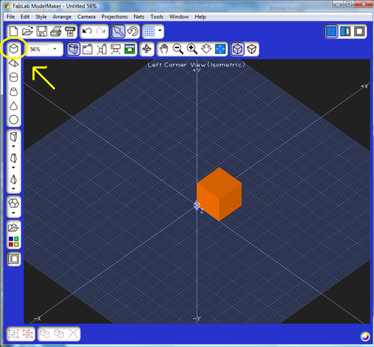

Ask students to define the following geometric concepts and identify them in the FabLab cube drawing.
  - face
From dictionary.com:
Face - any of the bounding surfaces of a solid figure
Edge - a line at which two surfaces of a solid object meet
Vertex - a point in a geometrical solid common to three or more sides OR the point farthest from the base
Polyhedron - A three-dimensional geometric figure whose sides are polygons
  - edge
  - vertex
  - polyhedron

Ask students to count the number of faces, edges, and vertices in the isometric view of the cube.

Rotate the cube (using the rotate icon highlighted below), and ask students to confirm their count of faces, vertices, and edges.

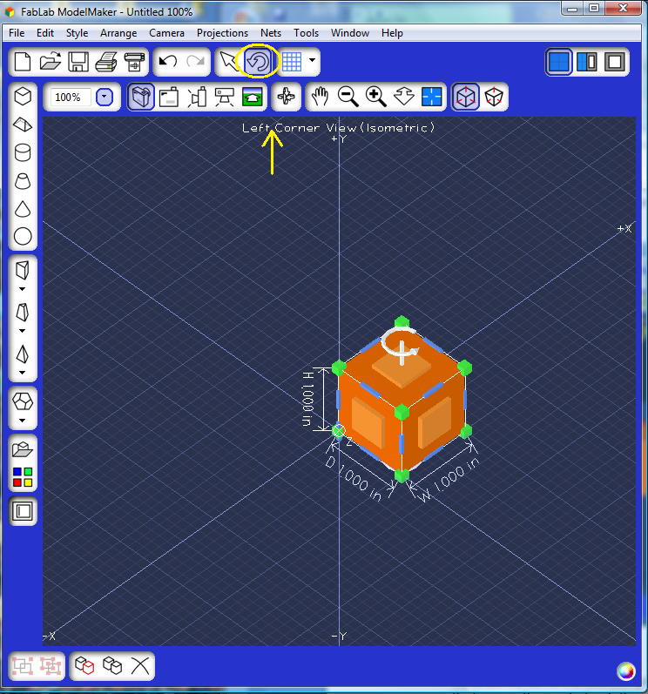
To rotate: Click the rotate button then click the object. The light orange squares dictate which axis you are rotating about. In the image to the left, the z axis is the axis of rotation. To change the axis, click another light orange square. Click and drag the green boxes in the corner to see the shape rotate.

To make this activity easier, you may color one (or more) sides of the cube. In order to do this, you must have the advanced toolbar. Go to tools and click on advance to display the toolbar. Use the select tool at the top of the screen to choose one side. Then, by using the color palette, add a color or design to that side.

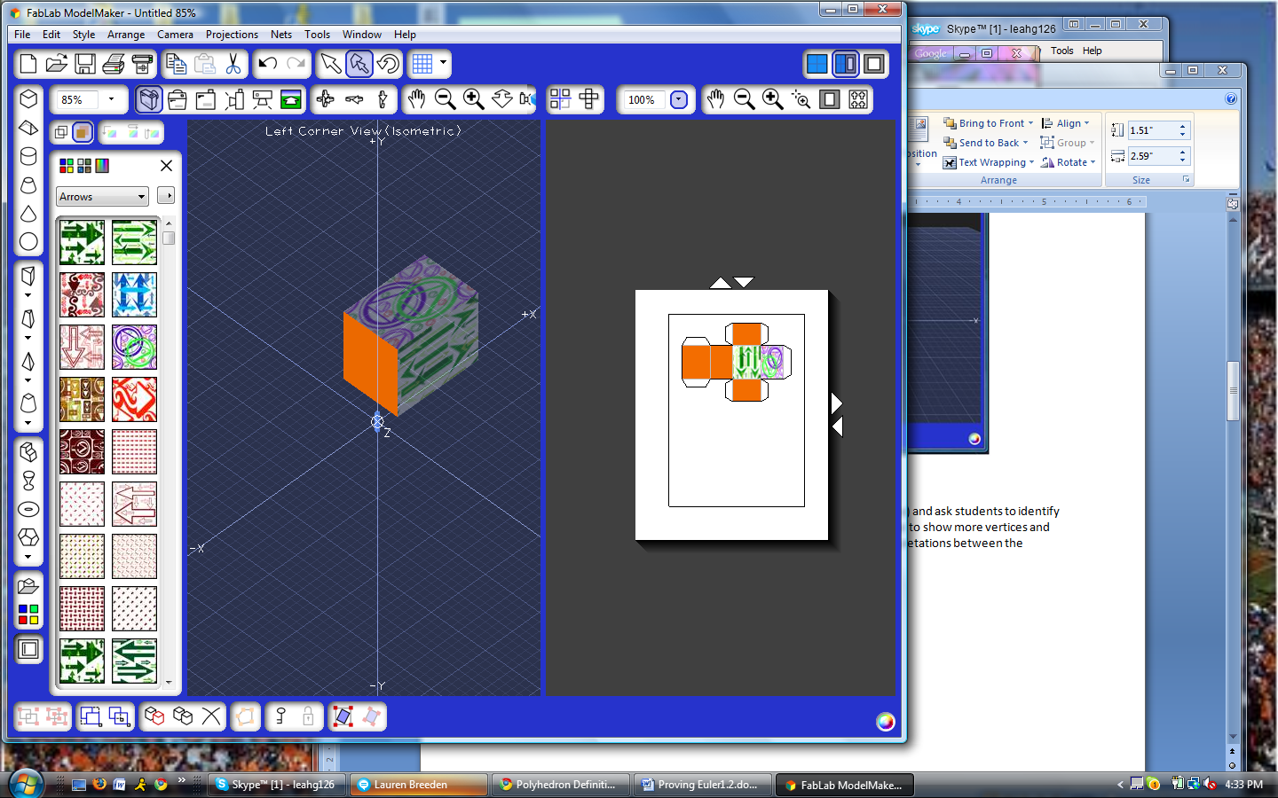
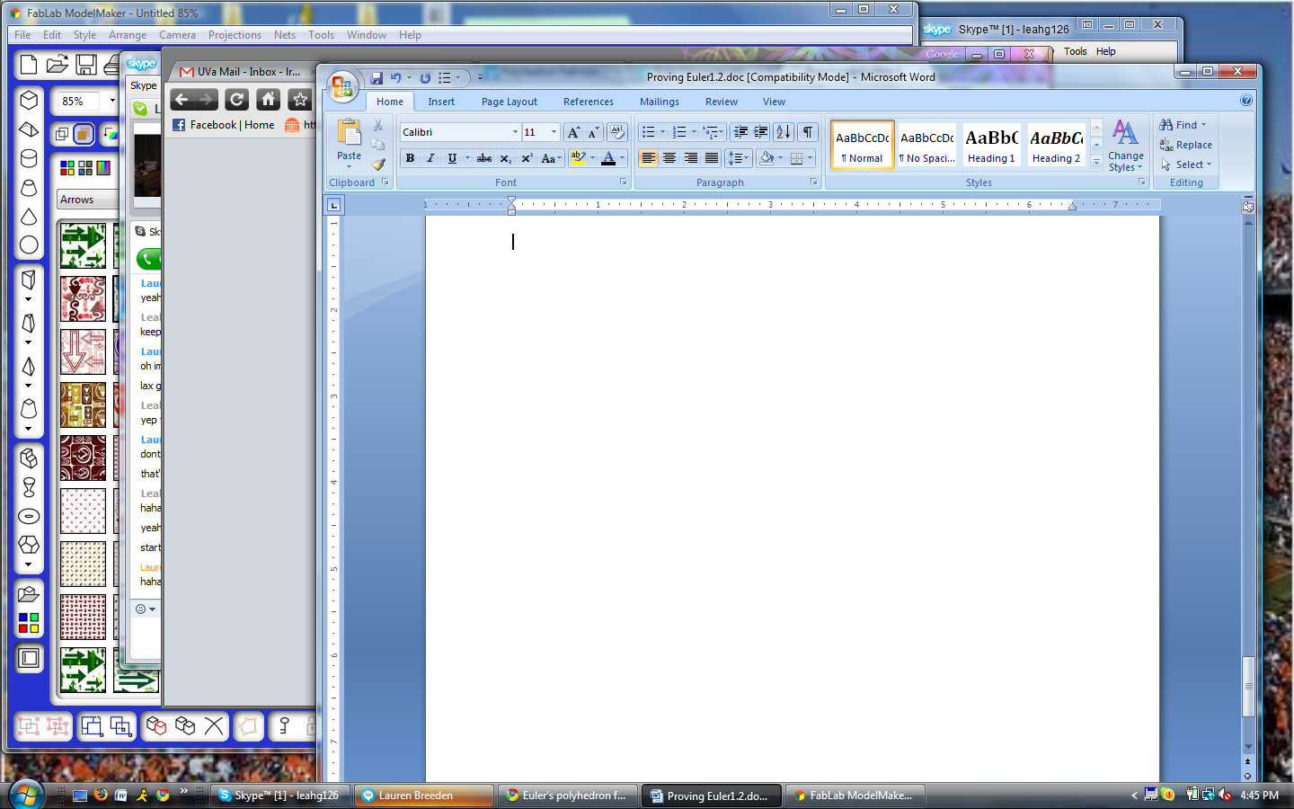

Generate the net for the cube (using the net icon highlighted below) and ask students to identify the faces, vertices, and edges in the net view. This view may appear to show more vertices and edges than the other views, so students must reconcile their interpretations in the different views and explain any discrepancies or illusions.

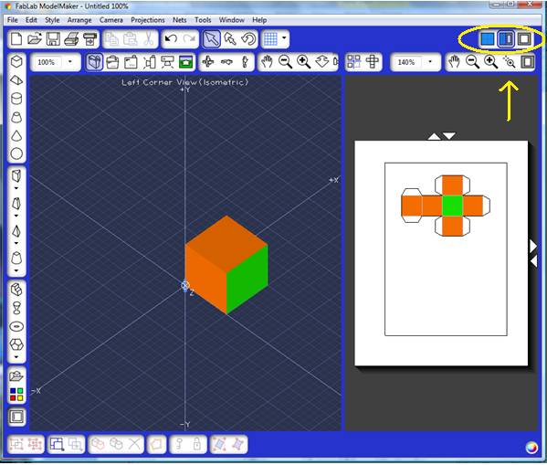

Students should now construct a cube with the Silhouette and identify the features.

Ask students to record their data by entering it into a table.

Shape | Vertices | Faces | Edges
Cube | 8 | 6 | 12
Tetrahedron
Octahedron
Dodecahedron
Icosahedron

Ask students to examine their data and find a relationship between these values. Have students explain their relationships.
Students should create the four other regular Platonic polyhedra using FabLab (see highlighted icon below).
Regular polyhedron - all the solid's faces are regular polygons with exactly the same number of sides, and that the same number of edges come out of each vertex of the solid.
From http://www.plus.maths.org
  - tetrahedron (4 triangular faces)
  - octahedron (8 triangular faces)
  - dodecahedron (12 pentagonal faces)
  - icosahedron (20 triangular faces)

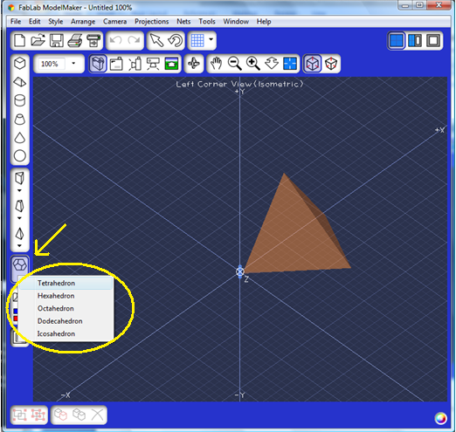

For each shape, students should count the number of faces, vertices, and edges, using the isometric, rotated, and net views, and then enter the data into their table.

Have a few different students print out their shapes on the Silhouette to construct 3-D models of all of the platonic solids and count the faces, edges and vertices on the 3-D models.

After they enter their data for each shape, they should verify that their found relationship between the numbers of faces, vertices, and edges applies to all of the shapes. If it does not, they need to find one that does apply to all shapes.

They should ultimately find that for each shape, Vertices + Faces - Edges = 2. This is known as Euler’s Characteristic Formula.

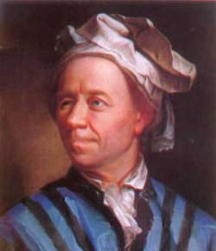
Euler was a very prolific mathematician who lived from 1707 – 1783.

Extension Activities:

Have students look at the 3D shapes on the toolbar on the left side of FabLab ModelMaker and predict which other solids will also satisfy Euler’s characteristic formula (i.e., have an Euler characteristic equal to 2). Ask students to construct some of these other solids with the Silhouette to test their predictions.

Have students also predict which 3D shapes will not satisfy the formula (i.e., have an Euler characteristic not equal to 2) and construct a solid to test their predictions.

Ask students to come up with conditions under a solid has an Euler characteristic of 2.

For more information, students can visit https://www.plus.maths.org to learn more about Euler and his work.

