Finding Volume of Prisms

Goals:
Students will use FabLab ModelMaker to explore the relationship between the dimensions of a prism and the volume of a prism. They will determine and explain the formula for the volume of a prism. Students will be introduced to the various features of FabLab ModelMaker, such as the cuboid function and the Properties menu.

Materials Needed:

FabLab ModelMaker software, a projector, a printer, a Silhouette cutter, and tape. Note: It is helpful to have some constructed cubes available for this activity.

Procedure:
Use, or preferably have students use, FabLab ModelMaker to draw a cube.
To draw a cube: click on the cube icon (see below), then click on a starting location on the grid, then drag the cursor to create a base, then click again to drag the cursor to adjust the height. Start with a 1x1x1 inch cube.

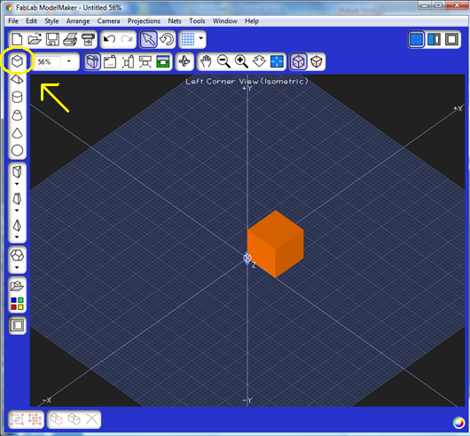
Use the Silhouette to create several 1x1x1 inch cubes, and pass them around for students to observe. (It is useful to have several of these cubes already constructed for this purpose.)
Ask students to make as many observations as they can about the cube. (Be sure to get comments on size, number of sides, number of dimensions, area of the sides, etc.)
Next, ask students how they would define the volume of a cube, and to explain or justify their definition.
From http://mathworld.wolfram.com:
Volume – (of a solid body) is the amount of space it occupies. Volume has units of length cubed.
Area – (of a surface) is the amount of material needed to cover it completely. Area has units of length squared.

Using their definition, have students determine this volume of the cube. Again, ask students to share their reasoning and steps.
In FabLab ModelMaker, right click on the cube. Go to Properties (see below).
The Properties menu shows the width, height, and depth of the solid, along with the values of each. It also gives the formula and value of the volume of the solid. (Note: The Properties menu has the definition of the solid, and shows key feature such as edges, vertices, surface area, etc.)
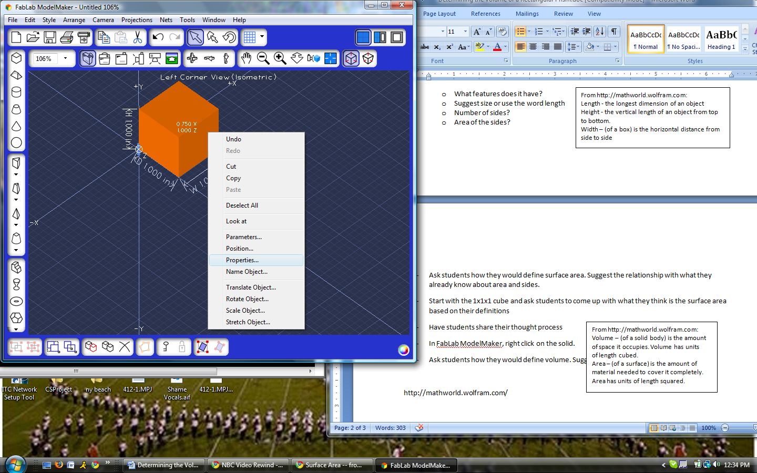

If you click on any value, the program will display the formula, so be sure not to do that until the students ultimately derive the formula.


Show students the calculated volume on the Properties menu. Students should compare their answers to the displayed value, and resolve any discrepancies. Again, discuss the definition of volume if needed.
Do this activity again, this time with a 1x2x3 rectangular prism. Note that such a prism can be constructed in different ways. Ask students to describe several of them. Have students determine the volume of this prism using their methods from the first cube
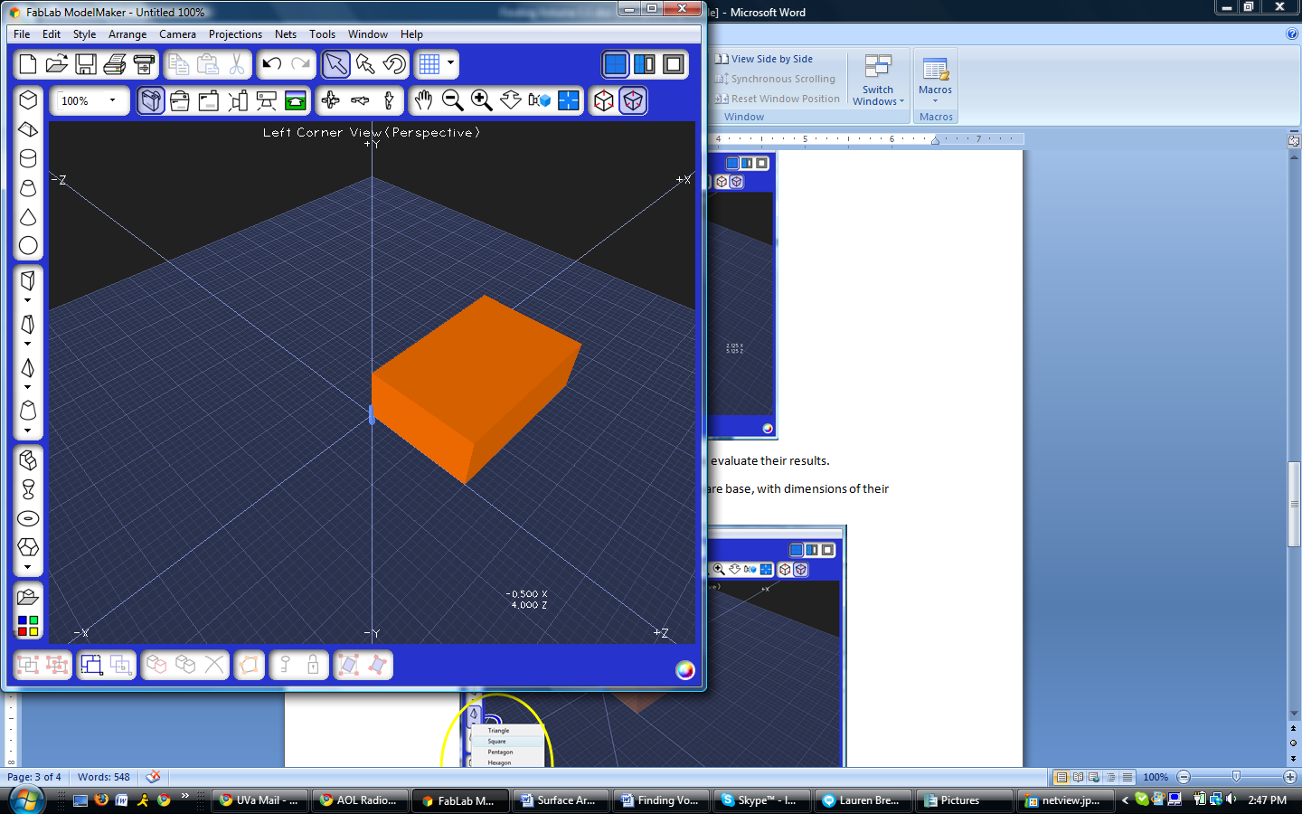
Again, students can go to the Properties menu of the larger cube to evaluate their results.
As in the previous activity, create several of these prisms, and pass them around for students to physically compare them with the 1x1x1 inch cubes. Students should observe and note connections between the prism and 1x1x1 cubes.
Students should now be able to give a descriptive formula for the volume of any rectangular prism. You can also ask students to create a third prism with different dimensions, if needed.

Extension Activity 1:
Do this activity a again, this time using a regular pyramid with a square base, with r = 1 (r refers to a generalized radius, so, r = 1 means a base side length of 2) and h = 3. Students should start by clicking on the pyramid icon and then clicking and dragging as before.

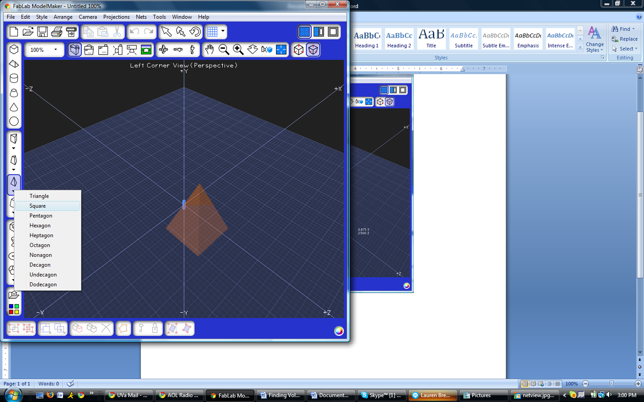
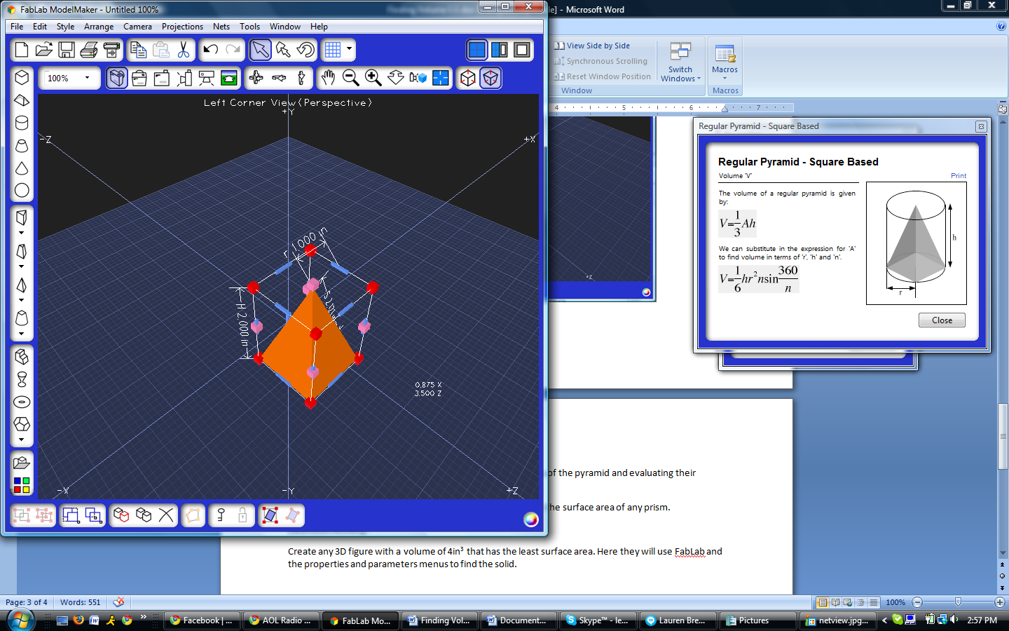

The drag feature may not easily yield desired parameters. To set the desired parameters, right click the solid and go to Parameters. Here you can enter whatever value you want to change the dimensions of the solid.
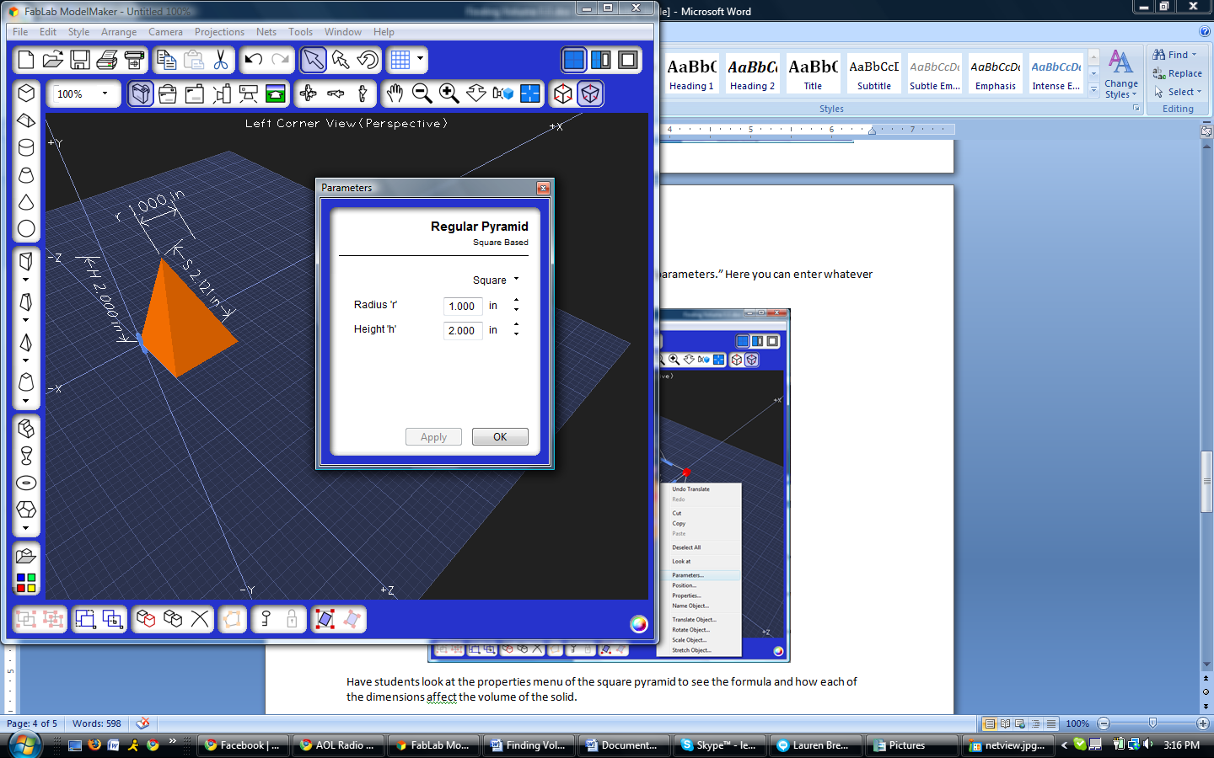
Ask students to determine the volume of this prism by referring to the volume of the previous prism. Students may have difficulty coming up with a way to calculate the volume of the pyramid, so suggest comparing the volume of this solid with a rectangular prism having the same dimensions (2x2x3). They can do this by constructing both a prism with these dimensions and a pyramid with these dimensions. It is helpful to put these solids side by side.
Have students look at the Properties menu of the square pyramid to see the actual value of the volume. Ask them how the volume may be connected to the base and height parameters, and to suggest a formula. They should draw several pyramids with FabLab ModelMaker, with different dimensions, and use the properties feature to verify their formulas.

Extension Activity 2:
Ask students to design a 3D figure with a volume of 4 in³ that has the least surface area. Here they will use FabLab Model Maker to draw different types of solids, and use Properties and Parameters menus to make sure they have the appropriate volume and find the surface area. Once they find a solid they believe has the least surface area, ask them to propose an explanation for their results.

