Finding Surface Area of Prisms
Goals:
Students will use FabLab ModelMaker to explore the relationship between the dimensions of a prism and the surface area of the prism. They will determine and explain the formula for the surface area. Students will be introduced to the various features of FabLab ModelMaker, such as the cuboid function and the properties menu.
Materials Needed:
FabLab ModelMaker software, a projector, a printer, a Silhouette cutter, and tape
Procedure:
Use, or preferably have students use, FabLab ModelMaker to draw a cube.
To draw a cube: click on the cube icon (see below), then click on a starting location on the grid, then drag the cursor to create a base, then click again to drag the cursor to adjust the height. Start with a 1x1x1 inch cube.

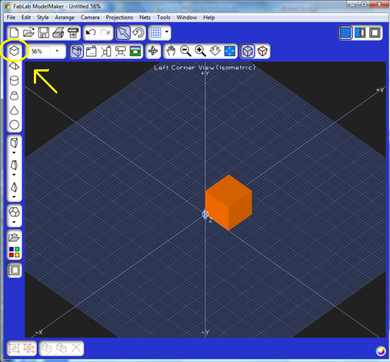
From http://mathworld.wolfram.com:
Volume – (of a solid body) is the amount of space it occupies. Volume has units of length cubed.
Area – (of a surface) is the amount of material needed to cover it completely. Area has units of length squared.

Ask students to make as many observations as they can about the cube. (Be sure to get comments on size, number of sides, number of dimensions, area of the sides, etc.)
Next, ask students how they would define the surface area of the cube. If necessary, suggest they think about what they already know about area and number of sides.
Use FabLab ModelMaker to display the net of the solid and use the Silhouette to construct the cube. This may help them to better visualize all of the surfaces and refine their definition. It is helpful to have some cubes available.
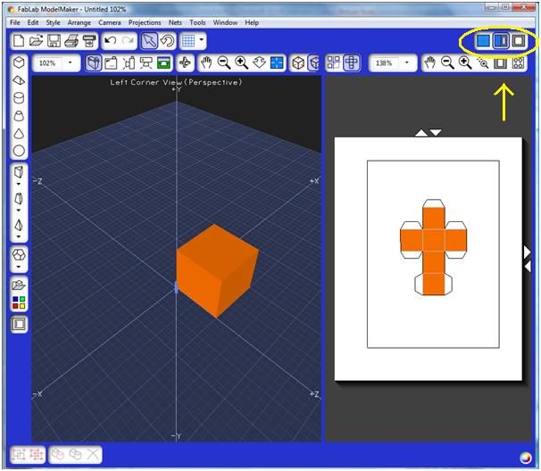
Using their definitions, have students determine the surface area of the cube. Have them share their thinking and reasoning. Discuss these definitions and student’s thinking.
In FabLab ModelMaker, right click on the cube. Go to Properties (see below).
The Properties menu shows the width, height, and depth of the solid along with the values of each. It also displays the value of the surface area. We will be using a few elements of the displayed area data. (Note: the Properties menu has the definition of the solid, and shows key features such as edges, vertices, etc. It gives the formulas for surface area and volume of the sold, but we’ll save these for later).

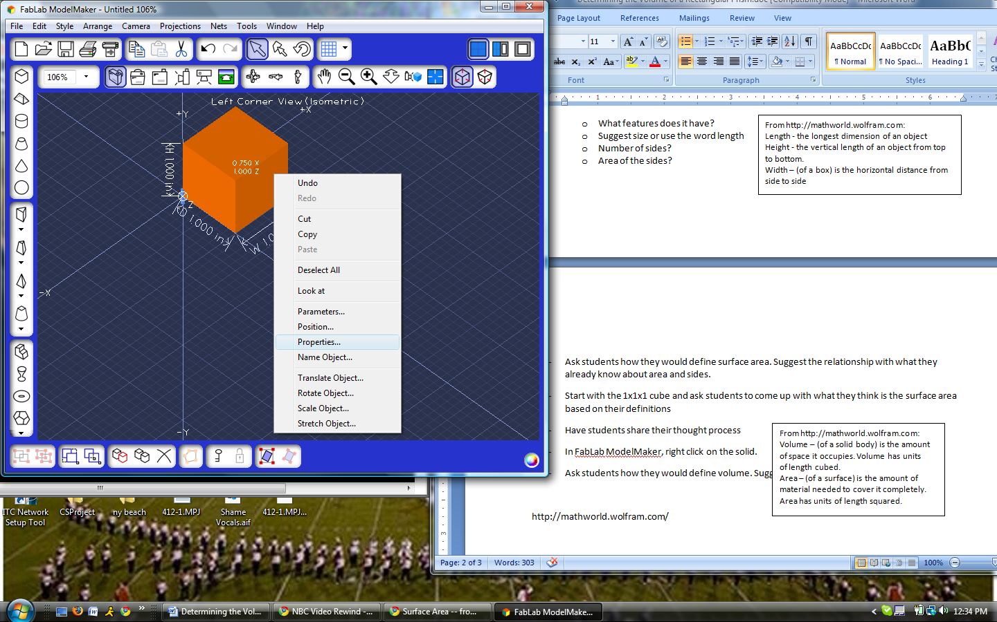


If you click on any value, the program will display the formula, so be sure not to do that until the students ultimately derive the formula.

Show students the displayed values of the areas of each of the surfaces on the cube. The easiest way for the students to interpret the values shown under Properties is to look at the cube displayed in the front view. This will show which face is the front face. Use the tilted front view option so that you can identify other sides as well.
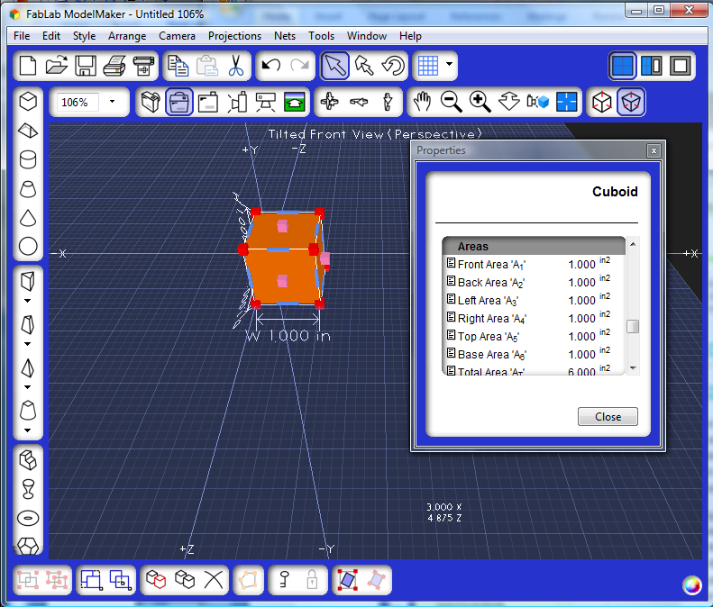
Students will see that the area of each face is 1in² and that the total area is 6 in². They should compare this to their answers. Using this information, ask students to create a formula for surface area or explain a process for calculating it.
Do this activity again, this time with a 1x2x3 rectangular prism. Such a prism can be constructed in different ways (e.g. 2x3x1). Ask students for these different ways. You can use FabLab to draw them and show their nets. Use the Silhouette to construct one such prism. Have students calculate the surface area of this prism, using their same methods from the cube.
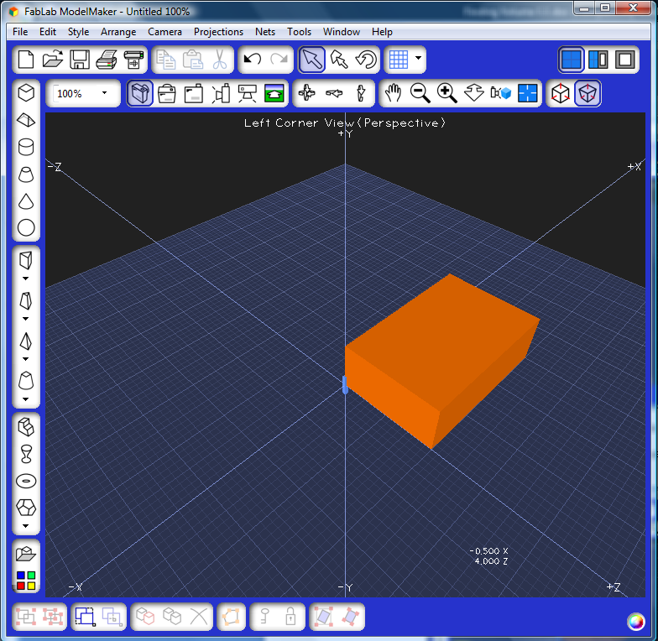
Again, students can go to the properties menu of the prism cube to evaluate their results.
Do this activity a third time, using a regular pyramid with a square base, with dimensions of their own choosing (see below). They should start by clicking on the pyramid icon, choosing a square base, and then clicking and dragging as before.

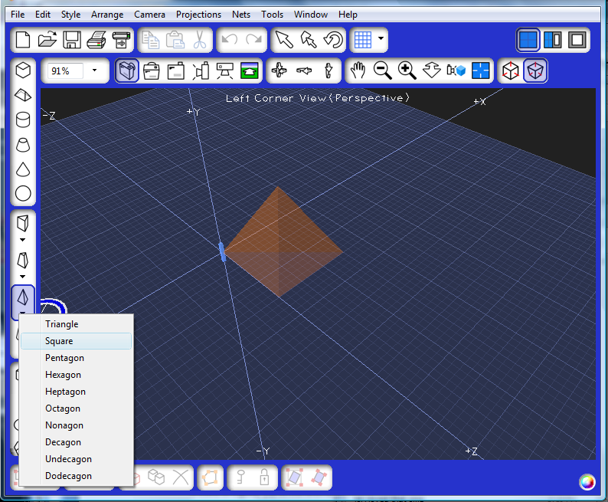
The drag feature may not easily yield the parameters they want. To set the desired parameters, right click the solid and go to Parameters. Here you can enter whatever values you want for the dimensions of the pyramid (see below).
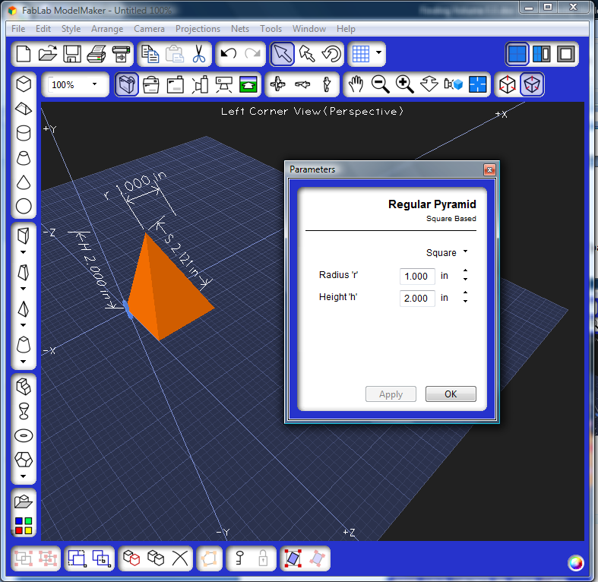
Have students go through the same steps above, and attempt to calculate the surface area of the pyramid. Note: they should know how to calculate the area of a triangle, but the height here is the height of the pyramid, not the (slant) height of the triangle. This may result in some confusion, but also create a teachable moment. Students may need to get the area of the sides from the Properties menu.
Students should now be able to give a descriptive formula for the surface area of any prism.
Extension Activity:
Ask students to create a cylinder with a radius of 1 inch and height of 2 inches, using the cylinder icon, and find the surface area of the cylinder using their definition from above. Note: Students will need to know how to find the area of circles prior to this; if not, this activity can be used a good lead in to the area of circles. Note: The net view can be very useful in this activity.
Students can also create a cone and conceptually explain how one would find the surface area. Have students look at the properties menu to see the values of the different parts of the cone and total surface area. This can set the stage for lessons on slant height and other properties of a cone.

